Installing Python on Windows
To install Python in Windows, head over to https://www.python.org/downloads/release/python-344/, scroll down the page until you see "Files" heading. There you will find different versions of Python that you can download.
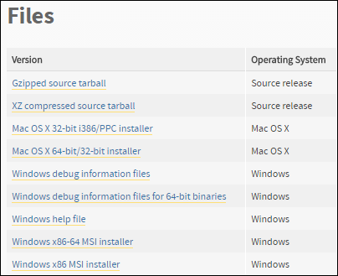
If you are using a 32-bit version of Windows download Windows x86 installer and if you are using a 64-bit version of Windows download Windows x86-64 installer. Note that Windows x86 installer will work on 32-bit as well as 64-bit.
After downloading the installer, double-click it to start the installation process. The installation is very straightforward, just accept all the defaults. The only critical step in the installation process is that when you are asked to Customize the Python installation.
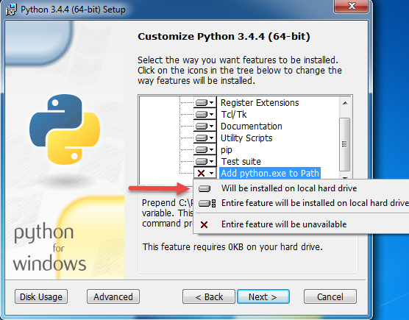
When this Window appears, use the scrollbar to scroll down the list. In front of the last item i.e "Add python.exe to Path", select "Will be installed on the local hard drive" using dropdown. This option allows us to call python.exe from any working directory in the Command Prompt without specifying the full path to it.
To verify the installation, open Command Prompt and enter the following command.
1  2  3 | C:\Users\Q>python --version  Python 3.4.4  C:\Users\Q>

